*Editor>>*

clc;

close all;

clear all;

im1=imread('livingroom.tif');

%Read the image

[r c]=size(im1); %Number of rows and columns

r_mask=input('Enter the number of rows: ');

%Number of rows of masking matrix

c_mask=input('Enter the number of columns: ');

%Number of columns of masking matrix

mask=input('Enter the masking matrix: '); %Masking matrix

r_add=((r_mask-1)/2); %Number of rows to be padded

c_add=((c_mask-1)/2); %Number of columns to be padded

padding=padarray(im1,[r_add c_add],0); %Zero Padding

pad_d=double(padding); %Integer into Double Datatype

for i=(1+r_add):(r+r_add)

for j=(1+c_add):(c+c_add)

sub_img=pad_d(i-r_add:i+r_add,j-c_add:j+c_add);

con_sum=sum(sum(mask .* sub_img)); %Convolution

result(i-r_add,j-c_add)=con_sum; %New Filtered image

end

end

im1=double(im1); %Integer into Double datatype

sharpening= result+im1; %Sharpening of Image

im1=uint8(im1); %Double into Integer datatype

subplot(1,2,1);

imshow(im1); %Display the Original image

title('Original Image');

subplot(1,2,2);

imshow(result); %Display the Filtered image

title('Filtered Image');

figure;

subplot(1,2,1);

imshow(im1); %Display the Original image

title('Orginal Image');

sharp=uint8(sharpening); %Double into Integer datatype

subplot(1,2,2);

imshow(sharp); %Display the Sharpened image

title('Sharpened Image');

*Command Window>>*

Enter the number of rows: 3

Enter the number of columns: 3

Enter the masking matrix: [ 1/9 1/9 1/9; 1/9 1/9 1/9; 1/9 1/9 1/9 ]

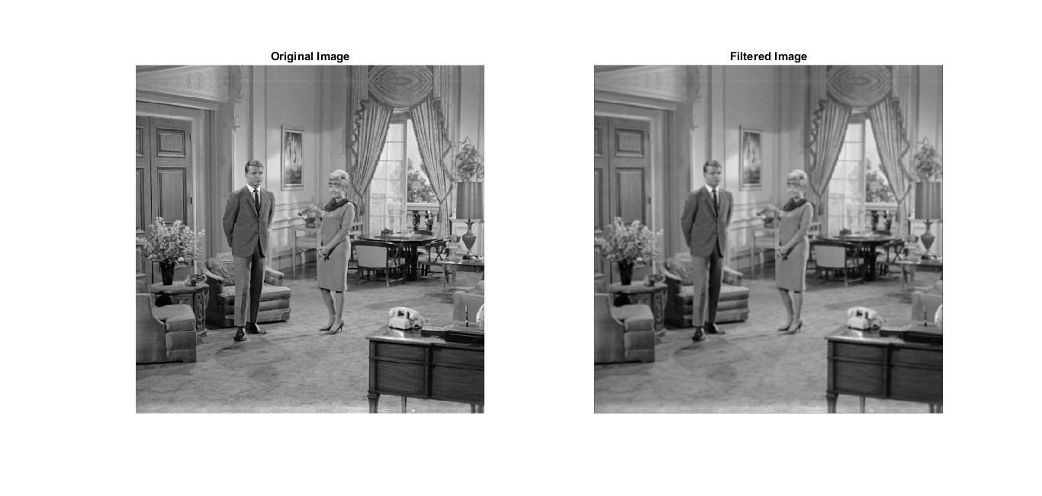

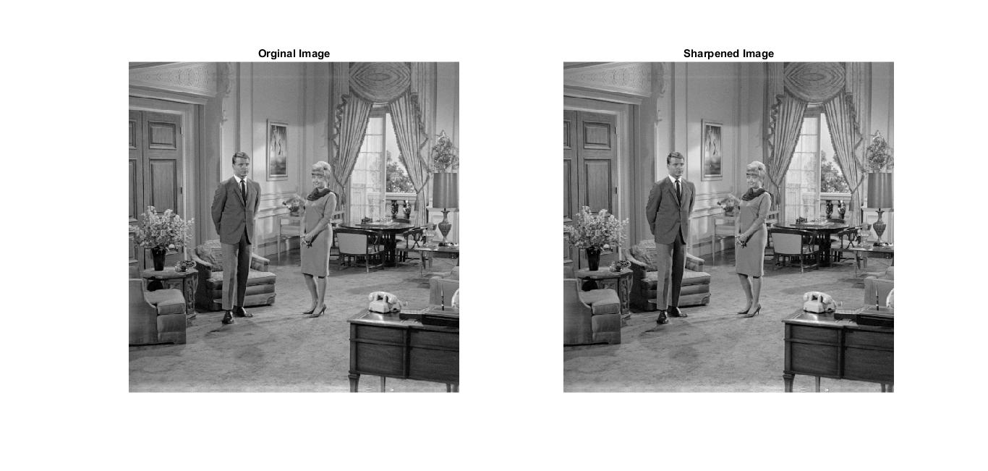

Enter the number of rows: 3

Enter the number of columns: 3

Enter the masking matrix: [ 1 1 1; 1 -8 1; 1 1 1 ]

